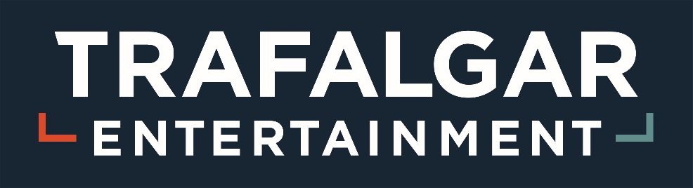

**ABOUT TRAFALGAR ENTERTAINMENT (TE)**

Co-founded by Sir Howard Panter and Dame Rosemary Squire in 2017, Trafalgar Entertainment is a premium international live entertainment business focussed on new productions, venue ownership, Performing Arts education, theatre ticketing, the distribution of live-streaming innovative content and the provision of great theatres where people can come together to share in the experience of live entertainment. TE is home to Trafalgar Theatres, The Chiswick Cinema, Trafalgar Theatre Productions, Trafalgar Releasing, Trafalgar Tickets, Stagecoach Performing Arts, Drama Kids/Helen O’Grady Drama Academy, ticketing company London Theatre Direct, Stagedoor, Jonathan Church Theatre Productions, and Imagine Theatre.

We are passionate about entertainment, audiences, and the live experience and we value **Creativity, Collaboration, Excellence** and **Respect.**

**ABOUT THIS ROLE**

The People department provides a comprehensive service to all subsidiaries within the TE Group. The focus of this role will be providing high quality administration support to the People team. You will be involved in a variety of day-to-day tasks relating to the employee life cycle as well as assisting with team projects.

You will be reporting to Head of People and Culture and the role will be based in our head office in Woking with occasional travel to our other sites within the UK.

This role is fixed term and is likely to end December 2026.

**ABOUT YOU**

You will present a professional and proactive approach with excellent communication skills. Self-motivated, with a strong sense of customer service, you will be flexible to ever-changing business priorities, have a calm attitude and be solution focused.

**KEY RESPONSIBILITIES**

* Support a diverse range of people administration duties, including emails, the preparation of resources, reports, documents, presentations, and other duties in conjunction with the HR software system (iTrent).
* Prepare and amend documents as necessary.
* Assist with all areas of the recruitment function including vacancy advertisements, interviewing and the onboarding process.
* Ensure all records are maintained, updated, and compliant with data protection laws.
* Oversee the employee life cycle on the HR system, including the monitoring of probationary reviews and return of documentation.
* Support the payroll department with workbook preparation as required.
* Create a calendar of administrative activities and diarise when due.
* Liaise with line managers and other administrators within the Group, acting as an initial point of contact for People and employee relations queries.
* End user (employee) support for HR system.
* Organise manual and e-filing, ensuring everything is up to date.
* Communicate regularly with key stakeholders and attend meetings as and when necessary.
* Organise and prepare meetings as and when appropriate.
* Take minutes and record actions, disseminating as appropriate.
* Support the People Team with various ongoing projects.
* HR system administration support
* Act always in accordance with TE’s values and ethics.
* Other ad hoc duties as and when required.

**SKILLS & EXPERIENCE**

* Friendly, personable, and able to communicate well at all levels.
* Team player with strong customer focus
* Good time management skills, able to prioritise and work effectively to deadlines.
* Strong attention to detail.
* Strong IT skills, particularly with the Microsoft Office Suite.
* Experience with HR system, PO system - desirable.
* Previous experience in a People/HR role, with a desire to develop those skills.
* CIPD Foundation Certificate in People Practice (Level 3) or working towards qualification – desirable.
* An interest in live entertainment/performance is desirable.

This Job Description is not an exhaustive description of your duties.  You will be required to adopt a flexible approach to your role and responsibilities.  From time to time, you may be required to undertake such alternative or additional duties as may be commensurate with your skills, experience, and capabilities.

If this sounds like you, we'd love to hear from you. Please submit your CV and Covering Letter as to why you think you are suitable for the role via the Recruitment Portal.

Trafalgar Entertainment is an equal opportunity employer. We celebrate diversity and are committed to creating an inclusive environment for all employees. We welcome applications from people in groups where we are under-represented, for example people with disabilities, from minority ethnic groups, older returners and people who are neurodivergent.

We are curious, courageous and ambitious, empowering people to challenge and innovate in pursuit of excellence.